**Excel Spreadsheet**

Microsoft Excel is an electronic spreadsheet. As with a paper spreadsheet, you can use Excel to organize your data into rows and columns and to perform mathematical calculations. The tutorial teaches you how to create an Excel spreadsheet.

**Lesson 1: Entering Text and Numbers**

|  |  |  |
| --- | --- | --- |
|  |  |  |

**The Microsoft Excel Window**

Microsoft Excel is an electronic spreadsheet. You can use it to organize your data into rows and columns. You can also use it to perform mathematical calculations quickly. This tutorial teaches Microsoft Excel basics. Although knowledge of how to navigate in a Windows environment is helpful, this tutorial was created for the computer novice.

This lesson will introduce you to the Excel window. You use the window to interact with Excel. To begin this lesson, start Microsoft Excel 2007. The Microsoft Excel window appears and your screen looks similar to the one shown here.

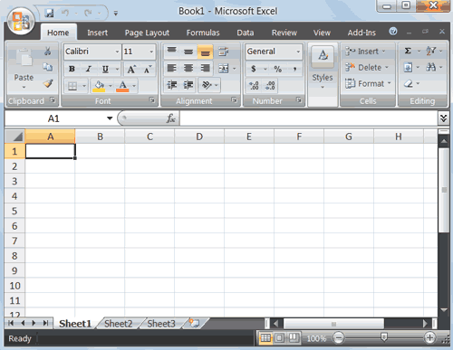

**Note:** Your screen will probably not look exactly like the screen shown. In Excel 2007, how a window displays depends on the size of your window, the size of your monitor, and the resolution to which your monitor is set. Resolution determines how much information your computer monitor can display. If you use a low resolution, less information fits on your screen, but the size of your text and images are larger. If you use a high resolution, more information fits on your screen, but the size of the text and images are smaller. Also, settings in Excel 2007, Windows Vista, and Windows XP allow you to change the color and style of your windows.

**The Microsoft Office Button**

**Office Button**

In the upper-left corner of the Excel 2007 window is the Microsoft Office button. When you click the button, a menu appears. You can use the menu to create a new file, open an existing file, save a file, and perform many other tasks.

**The Quick Access Toolbar**

**Quick Access Toolbar**

Next to the Microsoft Office button is the Quick Access toolbar. The Quick Access toolbar gives you with access to commands you frequently use. By default, Save, Undo, and Redo appear on the Quick Access toolbar. You can use Save to save your file, Undo to roll back an action you have taken, and Redo to reapply an action you have rolled back.

**The Title Bar**

**Title Bar**

Next to the Quick Access toolbar is the Title bar. On the Title bar, Microsoft Excel displays the name of the workbook you are currently using. At the top of the Excel window, you should see "Microsoft Excel - Book1" or a similar name.

**The Ribbon**

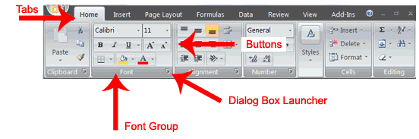

You use commands to tell Microsoft Excel what to do. In Microsoft Excel 2007, you use the Ribbon to issue commands. The Ribbon is located near the top of the Excel window, below the Quick Access toolbar. At the top of the Ribbon are several tabs; clicking a tab displays several related command groups. Within each group are related command buttons. You click buttons to issue commands or to access menus and dialog boxes. You may also find a dialog box launcher in the bottom-right corner of a group. When you click the dialog box launcher, a dialog box makes additional commands available.

**Worksheets**

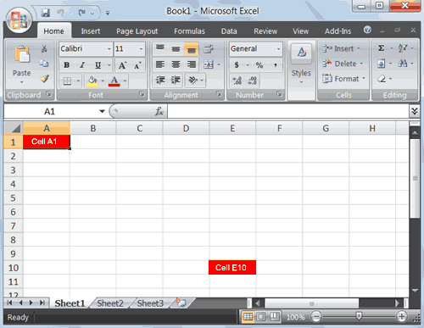

Microsoft Excel consists of worksheets. Each worksheet contains columns and rows. The columns are lettered A to Z and then continuing with AA, AB, AC and so on; the rows are numbered 1 to 1,048,576. The number of columns and rows you can have in a worksheet is limited by your computer memory and your system resources.

The combination of a column coordinate and a row coordinate make up a cell address. For example, the cell located in the upper-left corner of the worksheet is cell A1, meaning column A, row 1. Cell E10 is located under column E on row 10. You enter your data into the cells on the worksheet.

**The Formula Bar**

Formula bar  
Formula Bar

If the Formula bar is turned on, the cell address of the cell you are in displays in the Name box which is located on the left side of the Formula bar. Cell entries display on the right side of the Formula bar. If you do not see the Formula bar in your window, perform the following steps:

1. Choose the View tab.
2. Click Formula Bar in the Show/Hide group. The Formula bar appears.

**Note**: The current cell address displays on the left side of the Formula bar.

**The Status Bar**

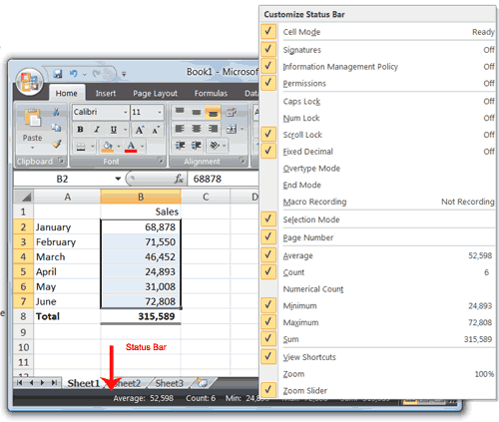

The Status bar appears at the very bottom of the Excel window and provides such information as the sum, average, minimum, and maximum value of selected numbers. You can change what displays on the Status bar by right-clicking on the Status bar and selecting the options you want from the Customize Status Bar menu. You click a menu item to select it. You click it again to deselect it. A check mark next to an item means the item is selected.

**Move Around a Worksheet**

By using the arrow keys, you can move around your worksheet. You can use the down arrow key to move downward one cell at a time. You can use the up arrow key to move upward one cell at a time. You can use the Tab key to move across the page to the right, one cell at a time. You can hold down the Shift key and then press the Tab key to move to the left, one cell at a time. You can use the right and left arrow keys to move right or left one cell at a time. The Page Up and Page Down keys move up and down one page at a time. If you hold down the Ctrl key and then press the Home key, you move to the beginning of the worksheet.

**EXERCISE 1**

**Move Around the Worksheet**

**The Down Arrow Key**

* Press the down arrow key several times. Note that the cursor moves downward one cell at a time.

**The Up Arrow Key**

* Press the up arrow key several times. Note that the cursor moves upward one cell at a time.

**The Tab Key**

1. Move to cell A1.
2. Press the Tab key several times. Note that the cursor moves to the right one cell at a time.

**The Shift+Tab Keys**

* Hold down the Shift key and then press Tab. Note that the cursor moves to the left one cell at a time.

**The Right and Left Arrow Keys**

1. Press the right arrow key several times. Note that the cursor moves to the right.
2. Press the left arrow key several times. Note that the cursor moves to the left.

**Page Up and Page Down**

1. Press the Page Down key. Note that the cursor moves down one page.
2. Press the Page Up key. Note that the cursor moves up one page.

***The Ctrl-Home Key***

1. Move the cursor to column J.
2. Stay in column J and move the cursor to row 20.
3. Hold down the Ctrl key while you press the Home key. Excel moves to cell A1.

**Go To Cells Quickly**

The following are shortcuts for moving quickly from one cell in a worksheet to a cell in a different part of the worksheet.

**EXERCISE 2**

**Go to -- F5**

The F5 function key is the "Go To" key. If you press the F5 key, you are prompted for the cell to which you wish to go. Enter the cell address, and the cursor jumps to that cell.

1. Press F5. The Go To dialog box opens.
2. Type **J3** in the Reference field.
3. Press Enter. Excel moves to cell J3.

**Go to -- Ctrl+G**

You can also use Ctrl+G to go to a specific cell.

1. Hold down the Ctrl key while you press "g" (Ctrl+g). The Go To dialog box opens.
2. Type **C4**in the Reference field.
3. Press Enter. Excel moves to cell C4.

**The Name Box**

You can also use the Name box to go to a specific cell. Just type the cell you want to go to in the Name box and then press Enter.

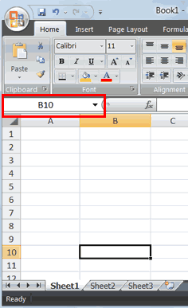

1. Type **B10** in the Name box.
2. Press Enter. Excel moves to cell B10.

**Select Cells**

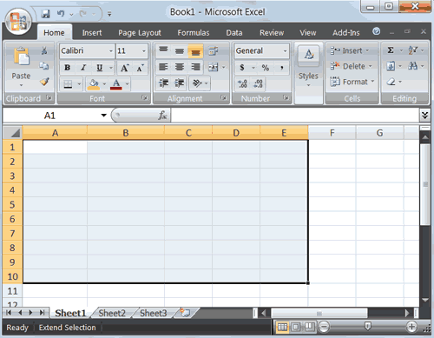

If you wish to perform a function on a group of cells, you must first select those cells by highlighting them. The exercises that follow teach you how to select.

**EXERCISE 3**

**Select Cells**

To select cells A1 to E1:

1. Go to cell A1.
2. Press the F8 key. This anchors the cursor.
3. Note that "Extend Selection" appears on the Status bar in the lower-left corner of the window. You are in the Extend mode.
4. Click in cell E7. Excel highlights cells A1 to E7.
5. Press Esc and click anywhere on the worksheet to clear the highlighting.

**Alternative Method: Select Cells by Dragging**

You can also select an area by holding down the left mouse button and dragging the mouse over the area. In addition, you can select noncontiguous areas of the worksheet by doing the following:

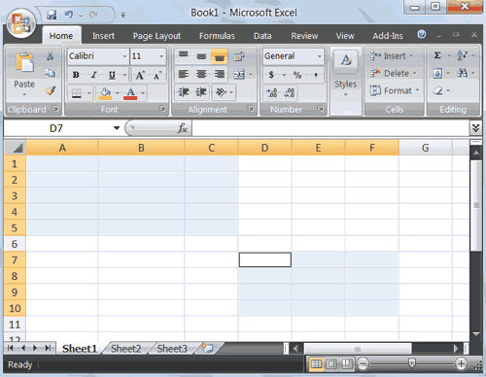

1. Go to cell A1.
2. Hold down the Ctrl key. You won't release it until step 9. Holding down the Ctrl key enables you to select noncontiguous areas of the worksheet.
3. Press the left mouse button.
4. While holding down the left mouse button, use the mouse to move from cell A1 to C5.
5. Continue to hold down the Ctrl key, but release the left mouse button.
6. Using the mouse, place the cursor in cell D7.
7. Press the left mouse button.
8. While holding down the left mouse button, move to cell F10. Release the left mouse button.
9. Release the Ctrl key. Cells A1 to C5 and cells D7 to F10 are selected.
10. Press Esc and click anywhere on the worksheet to remove the highlighting.

**Enter Data**

In this section, you will learn how to enter data into your worksheet. First, place the cursor in the cell in which you want to start entering data. Type some data, and then press Enter. If you need to delete, press the Backspace key to delete one character at a time.

**EXERCISE 4**

**Enter Data**

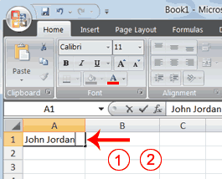

1. Place the cursor in cell A1.
2. Type **John Jordan**. Do not press Enter at this time.

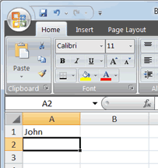

**Delete Data**

The Backspace key erases one character at a time.

1. Press the Backspace key until Jordan is erased.
2. Press Enter. The name "John" appears in cell A1.

**Edit a Cell**

After you enter data into a cell, you can edit the data by pressing F2 while you are in the cell you wish to edit.

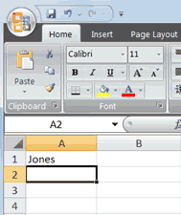

**EXERCISE 5**

**Edit a Cell**

Change "John" to "Jones."

1. Move to cell A1.
2. Press F2.
3. Use the Backspace key to delete the "n" and the "h."
4. Type **nes**.
5. Press Enter.

**Alternate Method: Editing a Cell by Using the Formula Bar**

You can also edit the cell by using the Formula bar. You change "Jones" to "Joker" in the following exercise.

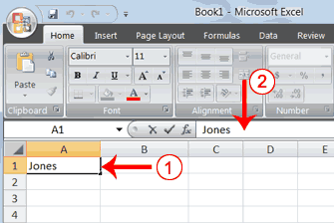

1. Move the cursor to cell A1.
2. Click in the formula area of the Formula bar.

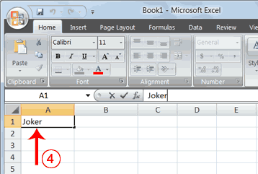

1. Use the backspace key to erase the "s," "e," and "n."
2. Type **ker**.
3. Press Enter.

**Alternate Method: Edit a Cell by Double-Clicking in the Cell**

You can change "Joker" to "Johnson" as follows:

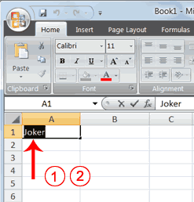

1. Move to cell A1.
2. Double-click in cell A1.
3. Press the End key. Your cursor is now at the end of your text.

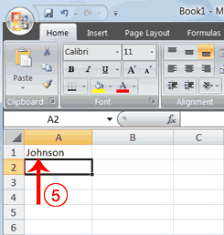

1. Use the Backspace key to erase "r," "e," and "k."
2. Type **hnson**.
3. Press Enter.

**Change a Cell Entry**

Typing in a cell replaces the old cell entry with the new information you type.

1. Move the cursor to cell A1.
2. Type **Cathy**.
3. Press Enter. The name "Cathy" replaces "Johnson."

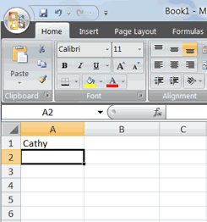

**Wrap Text**

When you type text that is too long to fit in the cell, the text overlaps the next cell. If you do not want it to overlap the next cell, you can wrap the text.

**EXERCISE 6**

**Wrap Text**

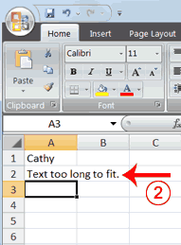

1. Move to cell A2.
2. Type **Text too long to fit**.
3. Press Enter.

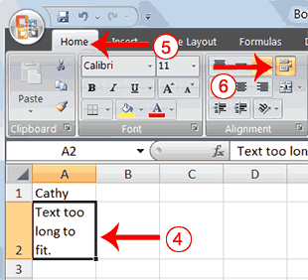

1. Return to cell A2.
2. Choose the Home tab.
3. Click the Wrap Text button Wrap Text Button. Excel wraps the text in the cell.

**Delete a Cell Entry**

To delete an entry in a cell or a group of cells, you place the cursor in the cell or select the group of cells and press Delete.

**EXERCISE 7**

**Delete a Cell Entry**

1. Select cells A1 to A2.
2. Press the Delete key.

**Save a File**

This is the end of Lesson1. To save your file:

1. Click the Office button. A menu appears.
2. Click Save. The Save As dialog box appears.
3. Go to the directory in which you want to save your file.
4. Type **Lesson1** in the File Name field.
5. Click Save. Excel saves your file.

**Close Excel**

Close Microsoft Excel.

1. Click the Office button. A menu appears.
2. Click Close. Excel closes.

**Excel Formulas**

When you enter formulas into your Excel worksheet, the formulas can calculate automatically. This lesson teaches you how to create an Excel formula.

|  |  |  |
| --- | --- | --- |
|  |  |  |

**Lesson 2: Entering Excel Formulas and Formatting Data**

Lesson 1 familiarized you with the Excel 2007 window, taught you how to move around the window, and how to enter data. A major strength of Excel is that you can perform mathematical calculations and format your data. In this lesson, you learn how to perform basic mathematical calculations and how to format text and numerical data. To start this lesson, open Excel.

**Set the Enter Key Direction**

In Microsoft Excel, you can specify the direction the cursor moves when you press the Enter key. In the exercises that follow, the cursor must move down one cell when you press Enter. You can use the Direction box in the Excel Options pane to set the cursor to move up, down, left, right, or not at all. Perform the steps that follow to set the cursor to move down when you press the Enter key.

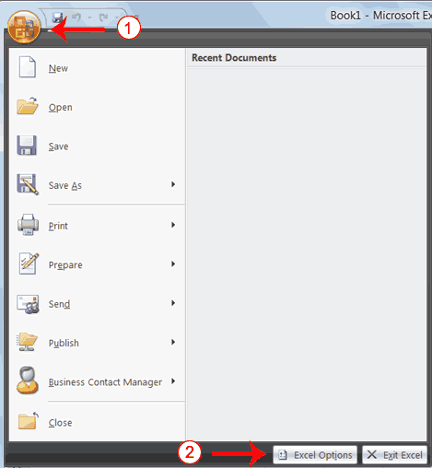

1. Click the Microsoft Office button. A menu appears.
2. Click Excel Options in the lower-right corner. The Excel Options pane appears.

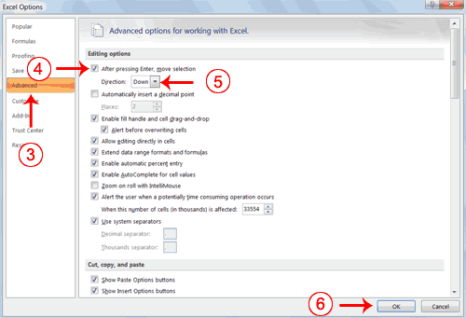

1. Click Advanced.
2. If the check box next to After Pressing Enter Move Selection is not checked, click the box to check it.
3. If Down does not appear in the Direction box, click the down arrow next to the Direction box and then click Down.
4. Click OK. Excel sets the Enter direction to down.

**Perform Mathematical Calculations**

In Microsoft Excel, you can enter numbers and mathematical formulas into cells. Whether you enter a number or a formula, you can reference the cell when you perform mathematical calculations such as addition, subtraction, multiplication, or division. When entering a mathematical formula, precede the formula with an equal sign. Use the following to indicate the type of calculation you wish to perform:

+ Addition

- Subtraction

* Multiplication

/ Division

^ Exponential

In the following exercises, you practice some of the methods you can use to move around a worksheet and you learn how to perform mathematical calculations. Refer to Lesson 1 to learn more about moving around a worksheet.

**EXERCISE 1**

**Addition**

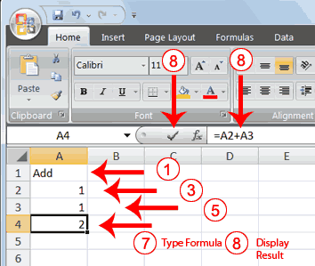

1. Type **Add** in cell A1.
2. Press Enter. Excel moves down one cell.
3. Type **1**in cell A2.
4. Press Enter. Excel moves down one cell.
5. Type **1** in cell A3.
6. Press Enter. Excel moves down one cell.
7. Type **=A2+A3** in cell A4.
8. Click the check mark on the Formula bar. Excel adds cell A1 to cell A2 and displays the result in cell A4. The formula displays on the Formula bar.

**Note:** Clicking the check mark on the Formula bar is similar to pressing Enter. Excel records your entry but does not move to the next cell.

**Subtraction**

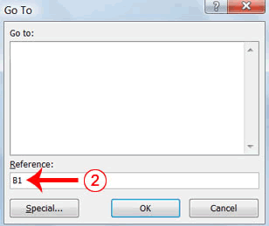

1. Press F5. The Go To dialog box appears.
2. Type **B1** in the Reference field.
3. Press Enter. Excel moves to cell B1.

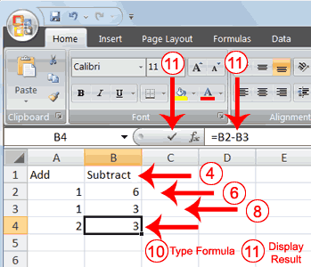

1. Type **Subtract**.
2. Press Enter. Excel moves down one cell.
3. Type **6** in cell B2.
4. Press Enter. Excel moves down one cell.
5. Type **3** in cell B3.
6. Press Enter. Excel moves down one cell.
7. Type **=B2-B3** in cell B4.
8. Click the check mark on the Formula bar. Excel subtracts cell B3 from cell B2 and the result displays in cell B4. The formula displays on the Formula bar.

**Multiplication**

1. Hold down the Ctrl key while you press "g" (Ctrl+g). The Go To dialog box appears.
2. Type **C1** in the Reference field.
3. Press Enter. Excel moves to cell C1
4. Type **Multiply**.
5. Press Enter. Excel moves down one cell.
6. Type **2** in cell C2.
7. Press Enter. Excel moves down one cell.
8. Type **3** in cell C3.
9. Press Enter. Excel moves down one cell.
10. Type **=C2*C3** in cell C4.
11. Click the check mark on the Formula bar. Excel multiplies C1 by cell C2 and displays the result in cell C3. The formula displays on the Formula bar.

**Division**

1. Press F5.
2. Type **D1** in the Reference field.
3. Press Enter. Excel moves to cell D1.
4. Type **Divide**.
5. Press Enter. Excel moves down one cell.
6. Type **6** in cell D2.
7. Press Enter. Excel moves down one cell.
8. Type **3** in cell D3.
9. Press Enter. Excel moves down one cell.
10. Type **=D2/D3** in cell D4.
11. Click the check mark on the Formula bar. Excel divides cell D2 by cell D3 and displays the result in cell D4. The formula displays on the Formula bar.

When creating formulas, you can reference cells and include numbers. All of the following formulas are valid:

=A2/B2

=A1+12-B3

=A2*B2+12

=24+53

**AutoSum**

You can use the AutoSum button AutoSum Button on the Home tab to automatically add a column or row of numbers. When you press the AutoSum button AutoSum Button, Excel selects the numbers it thinks you want to add. If you then click the check mark on the Formula bar or press the Enter key, Excel adds the numbers. If Excel's guess as to which numbers you want to add is wrong, you can select the cells you want.

**EXERCISE 2**

**AutoSum**

The following illustrates AutoSum:

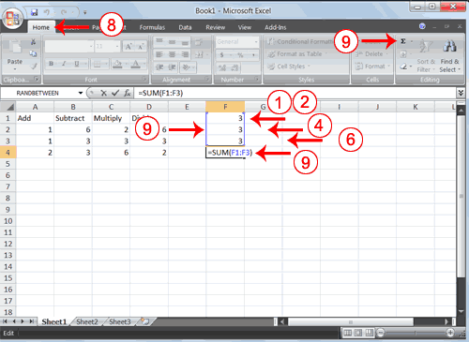

1. Go to cell F1.
2. Type **3.**
3. Press Enter. Excel moves down one cell.
4. Type **3**.
5. Press Enter. Excel moves down one cell.
6. Type **3**.
7. Press Enter. Excel moves down one cell to cell F4.
8. Choose the Home tab.
9. Click the AutoSum button AutoSum Button in the Editing group. Excel selects cells F1 through F3 and enters a formula in cell F4.

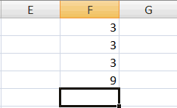

1. Press Enter. Excel adds cells F1 through F3 and displays the result in cell F4.

**Perform Automatic Calculations**

By default, Microsoft Excel recalculates the worksheet as you change cell entries. This makes it easy for you to correct mistakes and analyze a variety of scenarios.

**EXERCISE 3**

**Automatic Calculation**

Make the changes described below and note how Microsoft Excel automatically recalculates.

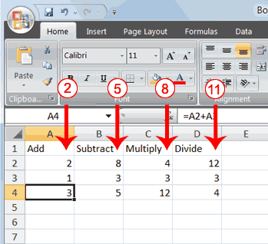

1. Move to cell A2.
2. Type **2**.
3. Press the right arrow key. Excel changes the result in cell A4. Excel adds cell A2 to cell A3 and the new result appears in cell A4.
4. Move to cell B2.
5. Type **8**.
6. Press the right arrow key.  Excel subtracts cell B3 from cell B3 and the new result appears in cell B4.
7. Move to cell C2.
8. Type **4**.
9. Press the right arrow key. Excel multiplies cell C2 by cell C3 and the new result appears in cell C4.
10. Move to cell D2.
11. Type **12**.
12. Press the Enter key. Excel divides cell D2 by cell D3 and the new result appears in cell D4.

**Align Cell Entries**

When you type text into a cell, by default your entry aligns with the left side of the cell. When you type numbers into a cell, by default your entry aligns with the right side of the cell. You can change the cell alignment. You can center, left-align, or right-align any cell entry. Look at cells A1 to D1. Note that they are aligned with the left side of the cell.

Align Left Example

**EXERCISE 4**

**Center**

To center cells A1 to D1:

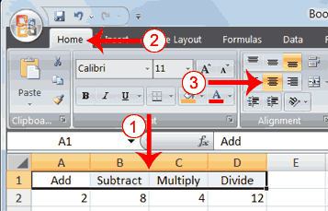

1. Select cells A1 to D1.
2. Choose the Home tab.
3. Click the Center button Center Button in the Alignment group. Excel centers each cell's content.

**Left-Align**

To left-align cells A1 to D1:

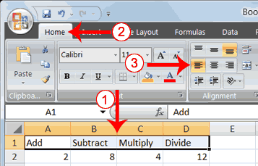

1. Select cells A1 to D1.
2. Choose the Home tab.
3. Click the Align Text Left Align Text Left button in the Alignment group. Excel left-aligns each cell's content.

**Right-Align**

To right-align cells A1 to D1:

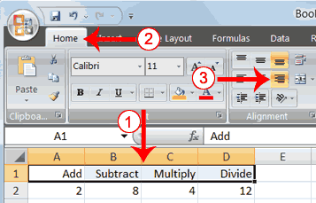

1. Select cells A1 to D1. Click in cell A1.
2. Choose the Home tab.
3. Click the Align Text Right Align Text Right button. Excel right-aligns the cell's content.
4. Click anywhere on your worksheet to clear the highlighting.

**Note:** You can also change the alignment of cells with numbers in them by using the alignment buttons.

**Perform Advanced Mathematical Calculations**

When you perform mathematical calculations in Excel, be careful of precedence. Calculations are performed from left to right, with multiplication and division performed before addition and subtraction.

**EXERCISE 5**

**Advanced Calculations**

1. Move to cell A7.
2. Type **=3+3+12/2*4**.
3. Press Enter.

**Note:** Microsoft Excel divides 12 by 2, multiplies the answer by 4, adds 3, and then adds another 3. The answer, 30, displays in cell A7.

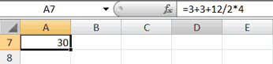

To change the order of calculation, use parentheses. Microsoft Excel calculates the information in parentheses first.

1. Double-click in cell A7.
2. Edit the cell to read **=(3+3+12)/2*4**.
3. Press Enter.

**Note:** Microsoft Excel adds 3 plus 3 plus 12, divides the answer by 2, and then multiplies the result by 4. The answer, 36, displays in cell A7.

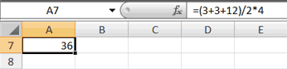

**Copy, Cut, Paste, and Cell Addressing**

In Excel, you can copy data from one area of a worksheet and place the data you copied anywhere in the same or another worksheet. In other words, after you type information into a worksheet, if you want to place the same information somewhere else, you do not have to retype the information. You simple copy it and then paste it in the new location.

You can use Excel's Cut feature to remove information from a worksheet.  Then you can use the Paste feature to place the information you cut anywhere in the same or another worksheet.   In other words, you can move information from one place in a worksheet to another place in the same or different worksheet by using the Cut and Paste features.

Microsoft Excel records cell addresses in formulas in three different ways, called *absolute*, *relative,* and *mixed*. The way a formula is recorded is important when you copy it. With relative cell addressing, when you copy a formula from one area of the worksheet to another, Excel records the position of the cell relative to the cell that originally contained the formula. With *absolute* cell addressing, when you copy a formula from one area of the worksheet to another, Excel references the same cells, no matter where you copy the formula. You can use mixed cell addressing to keep the row constant while the column changes, or vice versa. The following exercises demonstrate.

**EXERCISE 6**

**Copy, Cut, Paste, and Cell Addressing**

1. Move to cell A9.
2. Type **1**. Press Enter. Excel moves down one cell.
3. Type **1**. Press Enter. Excel moves down one cell.
4. Type **1**. Press Enter. Excel moves down one cell.
5. Move to cell B9.
6. Type **2**. Press Enter. Excel moves down one cell.
7. Type **2**. Press Enter. Excel moves down one cell.
8. Type **2**. Press Enter. Excel moves down one cell.

In addition to typing a formula as you did in Lesson 1, you can also enter formulas by using Point mode. When you are in Point mode, you can enter a formula either by clicking on a cell or by using the arrow keys.

1. Move to cell A12.
2. Type **=**.
3. Use the up arrow key to move to cell A9.
4. Type **+**.
5. Use the up arrow key to move to cell A10.
6. Type **+**.
7. Use the up arrow key to move to cell A11.
8. Click the check mark on the Formula bar. Look at the Formula bar. Note that the formula you entered is displayed there.

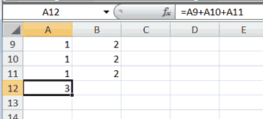

**Copy with the Ribbon**

To copy the formula you just entered, follow these steps:

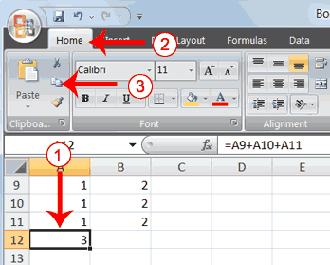

1. You should be in cell A12.
2. Choose the Home tab.
3. Click the Copy Copy Button button in the Clipboard group. Excel copies the formula in cell A12.

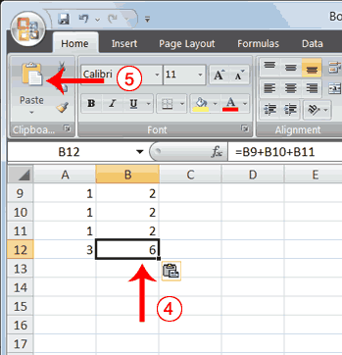

1. Press the right arrow key once to move to cell B12.
2. Click the Paste Paste Button button in the Clipboard group. Excel pastes the formula in cell A12 into cell B12.
3. Press the Esc key to exit the Copy mode.

Compare the formula in cell A12 with the formula in cell B12 (while in the respective cell, look at the Formula bar). The formulas are the same except that the formula in cell A12 sums the entries in column A and the formula in cell B12 sums the entries in column B. The formula was copied in a *relative* fashion.

Before proceeding with the next part of the exercise, you must copy the information in cells A7 to B9 to cells C7 to D9. This time you will copy by using the Mini toolbar.

**Copy with the Mini Toolbar**

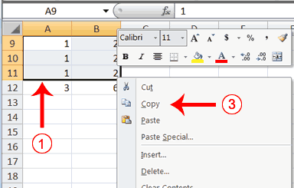

1. Select cells A9 to B11. Move to cell A9. Press the Shift key. While holding down the Shift key, press the down arrow key twice. Press the right arrow key once. Excel highlights A9 to B11.
2. Right-click. A context menu and a Mini toolbar appear.
3. Click Copy, which is located on the context menu. Excel copies the information in cells A9 to B11.

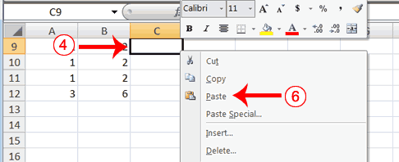

1. Move to cell C9.
2. Right-click. A context menu appears.
3. Click Paste. Excel copies the contents of cells A9 to B11 to cells C9 to C11.

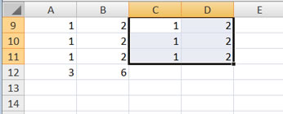

1. Press Esc to exit Copy mode.

**Absolute Cell Addressing**

You make a cell address an absolute cell address by placing a dollar sign in front of the row and column identifiers. You can do this automatically by using the F4 key. To illustrate:

1. Move to cell C12.
2. Type **=**.
3. Click cell C9.
4. Press F4. Dollar signs appear before the C and the 9.
5. Type **+**.
6. Click cell C10.
7. Press F4. Dollar signs appear before the C and the 10.
8. Type **+**.
9. Click cell C11.
10. Press F4. Dollar signs appear before the C and the 11.
11. Click the check mark on the formula bar. Excel records the formula in cell C12.

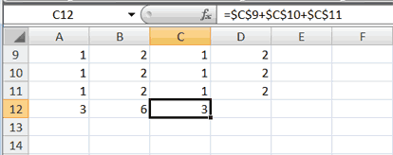

**Copy and Paste with Keyboard Shortcuts**

Keyboard shortcuts are key combinations that enable you to perform tasks by using the keyboard. Generally, you press and hold down a key while pressing a letter. For example, Ctrl+c means you should press and hold down the Ctrl key while pressing "c." This tutorial notates key combinations as follows:

Press Ctrl+c.

Now copy the formula from C12 to D12. This time, copy by using keyboard shortcuts.

1. Move to cell C12.
2. Hold down the Ctrl key while you press "c" (Ctrl+c). Excel copies the contents of cell C12.
3. Press the right arrow once. Excel moves to D12.
4. Hold down the Ctrl key while you press "v" (Ctrl+v). Excel pastes the contents of cell C12 into cell D12.
5. Press Esc to exit the Copy mode.

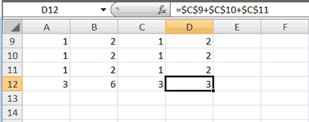

Compare the formula in cell C12 with the formula in cell D12 (while in the respective cell, look at the Formula bar). The formulas are exactly the same. Excel copied the formula from cell C12 to cell D12. Excel copied the formula in an*absolute* fashion. Both formulas sum column C.

**Mixed Cell Addressing**

You use mixed cell addressing to reference a cell when you want to copy part of it absolute and part relative. For example, the row can be absolute and the column relative. You can use the F4 key to create a mixed cell reference.

1. Move to cell E1.
2. Type **=**.
3. Press the up arrow key once.
4. Press F4.
5. Press F4 again. Note that the column is relative and the row is absolute.
6. Press F4 again. Note that the column is absolute and the row is relative.
7. Press Esc.

**Cut and Paste**

You can move data from one area of a worksheet to another.

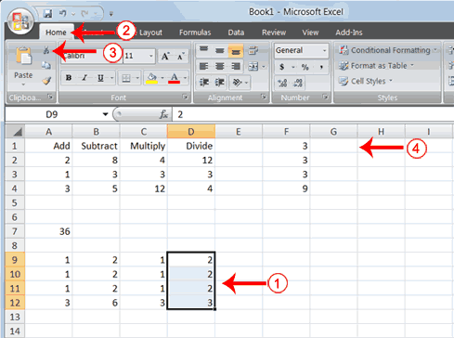

1. Select cells D9 to D12
2. Choose the Home tab.
3. Click the Cut Cut Button button.
4. Move to cell G1.

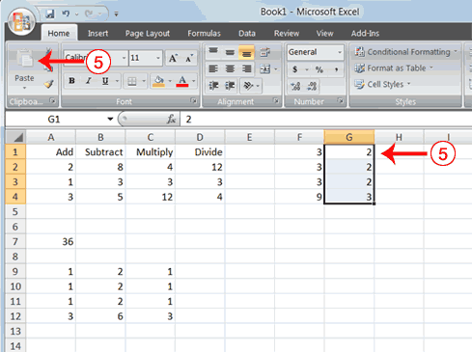

1. Click the Paste button Paste Button. Excel moves the contents of cells D9 to D12 to cells G1 to G4.

The keyboard shortcut for Cut is Ctrl+x. The steps for cutting and pasting with a keyboard shortcut are:

1. Select the cells you want to cut and paste.
2. Press Ctrl+x.
3. Move to the upper-left corner of the block of cells into which you want to paste.
4. Press Ctrl+v. Excel cuts and pastes the cells you selected.

**Insert and Delete Columns and Rows**

You can insert and delete columns and rows. When you delete a column, you delete everything in the column from the top of the worksheet to the bottom of the worksheet. When you delete a row, you delete the entire row from left to right. Inserting a column or row inserts a completely new column or row.

**EXERCISE 7**

**Insert and Delete Columns and Rows**

To delete columns F and G:

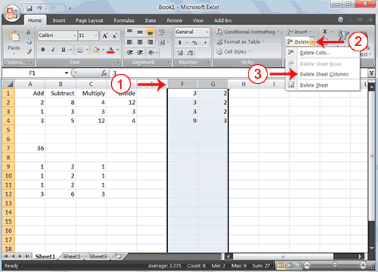

1. Click the column F indicator and drag to column G.
2. Click the down arrow next to Delete in the Cells group. A menu appears.
3. Click Delete Sheet Columns. Excel deletes the columns you selected.
4. Click anywhere on the worksheet to remove your selection.

To delete rows 7 through 12:

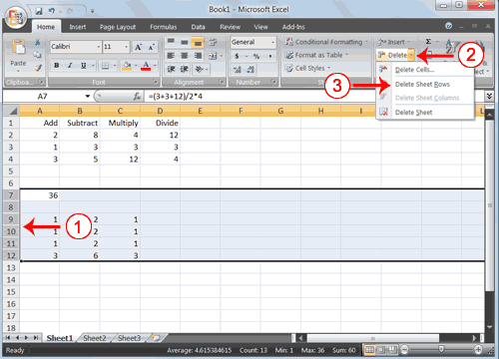

1. Click the row 7 indicator and drag to row 12.
2. Click the down arrow next to Delete in the Cells group. A menu appears.
3. Click Delete Sheet Rows. Excel deletes the rows you selected.
4. Click anywhere on the worksheet to remove your selection.

To insert a column:

1. Click on A to select column A.
2. Click the down arrow next to Insert in the Cells group. A menu appears.
3. Click Insert Sheet Columns. Excel inserts a new column.
4. Click anywhere on the worksheet to remove your selection.

To insert rows:

1. Click on 1 and then drag down to 2 to select rows 1 and 2.
2. Click the down arrow next to Insert in the Cells group. A menu appears.
3. Click Insert Sheet Rows. Excel inserts two new rows.
4. Click anywhere on the worksheet to remove your selection.

Your worksheet should look like the one shown here.

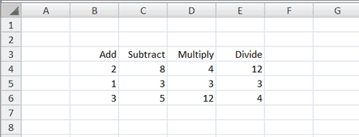

**Create Borders**

You can use borders to make entries in your Excel worksheet stand out. You can choose from several types of borders. When you press the down arrow next to the Border button Border Button, a menu appears. By making the proper selection from the menu, you can place a border on the top, bottom, left, or right side of the selected cells; on all sides; or around the outside border. You can have a thick outside border or a border with a single-line top and a double-line bottom. Accountants usually place a single underline above a final number and a double underline below. The following illustrates:

**EXERCISE 8**

**Create Borders**

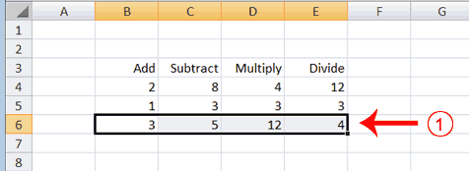

1. Select cells B6 to E6.

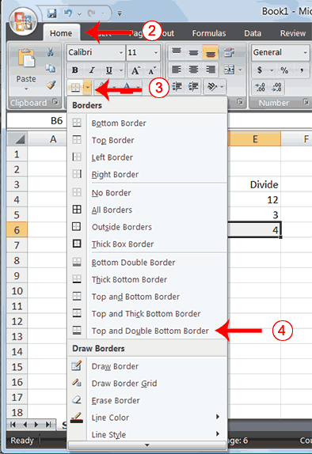

1. Choose the Home tab.
2. Click the down arrow next to the Borders button Border Button. A menu appears.
3. Click Top and Double Bottom Border. Excel adds the border you chose to the selected cells.

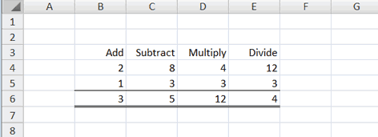

**Merge and Center**

Sometimes, particularly when you give a title to a section of your worksheet, you will want to center a piece of text over several columns or rows. The following example shows you how.

**EXERCISE 9**

**Merge and Center**

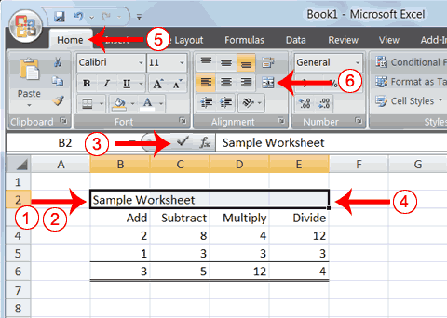

1. Go to cell B2.
2. Type **Sample Worksheet**.
3. Click the check mark on the Formula bar.
4. Select cells B2 to E2.
5. Choose the Home tab.
6. Click the Merge and Center button Merger & Center Button in the Alignment group. Excel merges cells B2, C2, D2, and E2 and then centers the content.

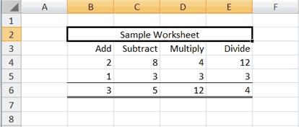

**Note:** To unmerge cells:

1. Select the cell you want to unmerge.
2. Choose the Home tab.
3. Click the down arrow next to the Merge and Center button.Merge & Center Button A menu appears.
4. Click Unmerge Cells. Excel unmerges the cells.

**Add Background Color**

To make a section of your worksheet stand out, you can add background color to a cell or group of cells.

**EXERCISE 10**

**Add Background Color**

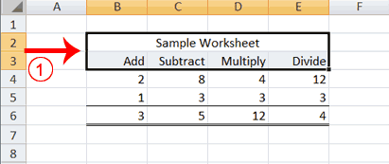

1. Select cells B2 to E3.

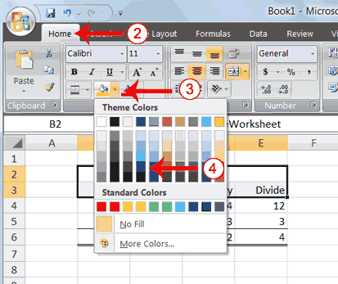

1. Choose the Home tab.
2. Click the down arrow next to the Fill Color button Fill Color Button.
3. Click the color dark blue. Excel places a dark blue background in the cells you selected.

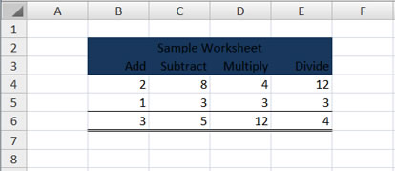

**Change the Font, Font Size, and Font Color**

A font is a set of characters represented in a single typeface. Each character within a font is created by using the same basic style. Excel provides many different fonts from which you can choose. The size of a font is measured in points. There are 72 points to an inch. The number of points assigned to a font is based on the distance from the top to the bottom of its longest character. You can change the Font, Font Size, and Font Color of the data you enter into Excel.

**EXERCISE 11**

**Change the Font**

1. Select cells B2 to E3.

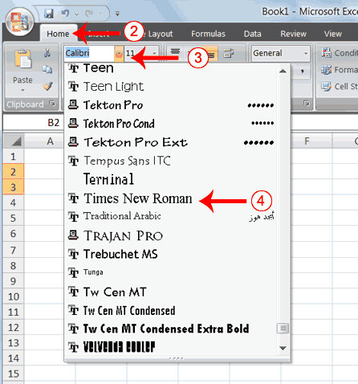

1. Choose the Home tab.
2. Click the down arrow next to the Font box. A list of fonts appears. As you scroll down the list of fonts, Excel provides a preview of the font in the cell you selected.
3. Find and click Times New Roman in the Font box. **Note:** If Times New Roman is your default font, click another font. Excel changes the font in the selected cells.

**Change the Font Size**

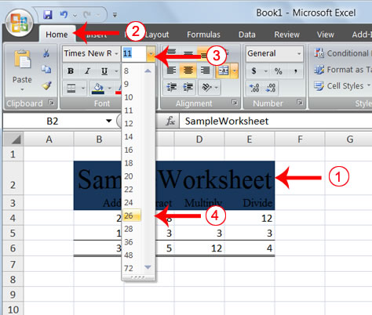

1. Select cell B2.
2. Choose the Home tab.
3. Click the down arrow next to the Font Size box. A list of font sizes appears. As you scroll up or down the list of font sizes, Excel provides a preview of the font size in the cell you selected.
4. Click 26. Excel changes the font size in cell B2 to 26.

**Change the Font Color**

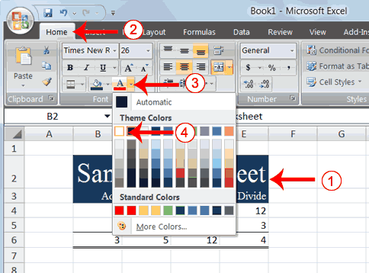

1. Select cells B2 to E3.
2. Choose the Home tab.
3. Click the down arrow next to the Font Color button Font Color Button.
4. Click on the color white. Your font color changes to white.

Your worksheet should look like the one shown here.

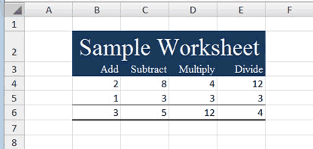

**Move to a New Worksheet**

In Microsoft Excel, each workbook is made up of several worksheets. Each worksheet has a tab. By default, a workbook has three sheets and they are named sequentially, starting with Sheet1. The name of the worksheet appears on the tab. Before moving to the next topic, move to a new worksheet. The exercise that follows shows you how.

**EXERCISE 12**

**Move to a New Worksheet**

* Click Sheet2 in the lower-left corner of the screen. Excel moves to Sheet2.

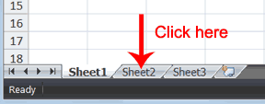

**Bold, Italicize, and Underline**

When creating an Excel worksheet, you may want to emphasize the contents of cells by bolding, italicizing, and/or underlining. You can easily bold, italicize, or underline text with Microsoft Excel. You can also combine these features—in other words, you can bold, italicize, and underline a single piece of text.

In the exercises that follow, you will learn different methods you can use to bold, italicize, and underline.

**EXERCISE 13**

**Bold with the Ribbon**

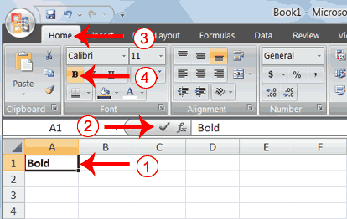

1. Type **Bold** in cell A1.
2. Click the check mark located on the Formula bar.
3. Choose the Home tab.
4. Click the Bold button Bold Button. Excel bolds the contents of the cell.
5. Click the Bold button Bold Button again if you wish to remove the bold.

**Italicize with the Ribbon**

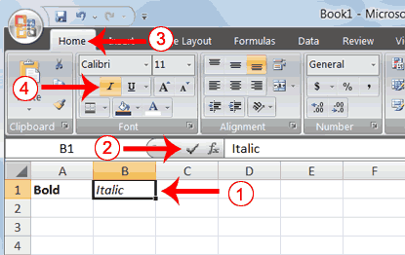

1. Type **Italic** in cell B1.
2. Click the check mark located on the Formula bar.
3. Choose the Home tab.
4. Click the Italic button Italic Button. Excel italicizes the contents of the cell.
5. Click the Italic button Italic Button again if you wish to remove the italic.

**Underline with the Ribbon**

Microsoft Excel provides two types of underlines. The exercises that follow illustrate them.

Single Underline:

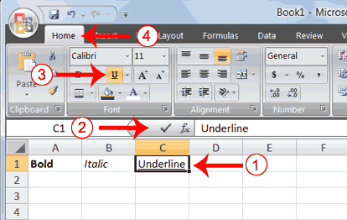

1. Type **Underline** in cell C1.
2. Click the check mark located on the Formula bar.
3. Choose the Home tab.
4. Click the Underline button Underline Button. Excel underlines the contents of the cell.
5. Click the Underline button Underline Button again if you wish to remove the underline.

**Double Underline**

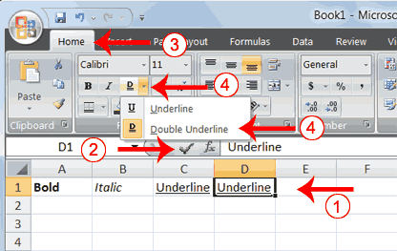

1. Type **Underline** in cell D1.
2. Click the check mark located on the Formula bar.
3. Choose the Home tab.
4. Click the down arrow next to the Underline button Underline Button and then click Double Underline. Excel double-underlines the contents of the cell. Note that the Underline button changes to the button shown here Double Underline Button, a D with a double underline under it. Then next time you click the Underline button, you will get a double underline. If you want a single underline, click the down arrow next to the Double Underline button Double Underline Button and then choose Underline.
5. Click the double underline button again if you wish to remove the double underline.

**Bold, Underline, and Italicize**

1. Type **All three** in cell E1.
2. Click the check mark located on the Formula bar.
3. Choose the Home tab.
4. Click the Bold button Bold Button. Excel bolds the cell contents.
5. Click the Italic button Italic Button. Excel italicizes the cell contents.
6. Click the Underline button Underline Button. Excel underlines the cell contents.

**Alternate Method: Bold with Shortcut Keys**

1. Type **Bold** in cell A2.
2. Click the check mark located on the Formula bar.
3. Hold down the Ctrl key while pressing "b" (Ctrl+b). Excel bolds the contents of the cell.
4. Press Ctrl+b again if you wish to remove the bolding.

**Alternate Method: Italicize with Shortcut Keys**

1. Type **Italic** in cell B2. **Note:** Because you previously entered the word Italic in column B, Excel may enter the word in the cell automatically after you type the letter I. Excel does this to speed up your data entry.
2. Click the check mark located on the Formula bar.
3. Hold down the Ctrl key while pressing "i" (Ctrl+i). Excel italicizes the contents of the cell.
4. Press Ctrl+i again if you wish to remove the italic formatting.

**Alternate Method: Underline with Shortcut Keys**

1. Type **Underline** in cell C2.
2. Click the check mark located on the Formula bar.
3. Hold down the Ctrl key while pressing "u" (Ctrl+u). Excel applies a single underline to the cell contents.
4. Press Ctrl+u again if you wish to remove the underline.

**Bold, Italicize, and Underline with Shortcut Keys**

1. Type **All three** in cell D2.
2. Click the check mark located on the Formula bar.
3. Hold down the Ctrl key while pressing "b" (Ctrl+b). Excel bolds the cell contents.
4. Hold down the Ctrl key while pressing "i" (Ctrl+i). Excel italicizes the cell contents.
5. Hold down the Ctrl key while pressing "u" (Ctrl+u). Excel applies a single underline to the cell contents.

**Work with Long Text**

Whenever you type text that is too long to fit into a cell, Microsoft Excel attempts to display all the text. It left-aligns the text regardless of the alignment you have assigned to it, and it borrows space from the blank cells to the right. However, a long text entry will never write over cells that already contain entries—instead, the cells that contain entries cut off the long text. The following exercise illustrates this.

**EXERCISE 14**

**Work with Long Text**

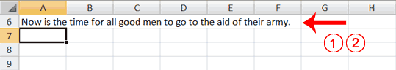

1. Move to cell A6.
2. Type **Now is the time for all good men to go to the aid of their army**.
3. Press Enter. Everything that does not fit into cell A6 spills over into the adjacent cell.

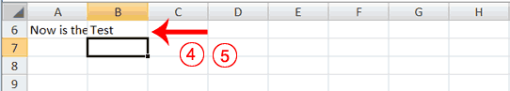

1. Move to cell B6.
2. Type **Test**.
3. Press Enter. Excel cuts off the entry in cell A6.

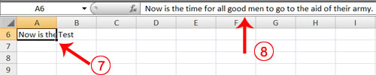

1. Move to cell A6.
2. Look at the Formula bar. The text is still in the cell.

**Change A Column's Width**

You can increase column widths. Increasing the column width enables you to see the long text.

**EXERCISE 15**

**Change Column Width**

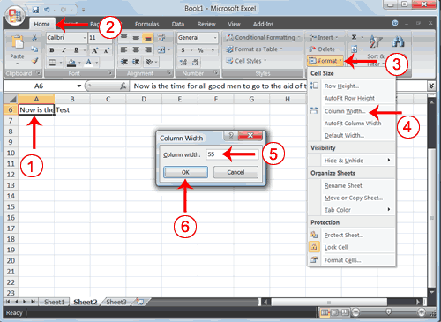

1. Make sure you are in any cell under column A.
2. Choose the Home tab.
3. Click the down arrow next to Format in the Cells group.
4. Click Column Width. The Column Width dialog box appears.
5. Type **55** in the Column Width field.
6. Click OK. Column A is set to a width of 55. You should now be able to see all of the text.

Change Column Width Result

**Change a Column Width by Dragging**

You can also change the column width with the cursor.

1. Place the mouse pointer on the line between the B and C column headings. The mouse pointer should look like the one displayed here Width Pointer, with two arrows.
2. Move your mouse to the right while holding down the left mouse button. The width indicator Width Indicator appears on the screen.
3. Release the left mouse button when the width indicator shows approximately 20. Excel increases the column width to 20.

**Format Numbers**

You can format the numbers you enter into Microsoft Excel. For example, you can add commas to separate thousands, specify the number of decimal places, place a dollar sign in front of a number, or display a number as a percent.

**EXERCISE 16**

**Format Numbers**

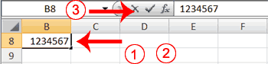

1. Move to cell B8.
2. Type **1234567**.
3. Click the check mark on the Formula bar.

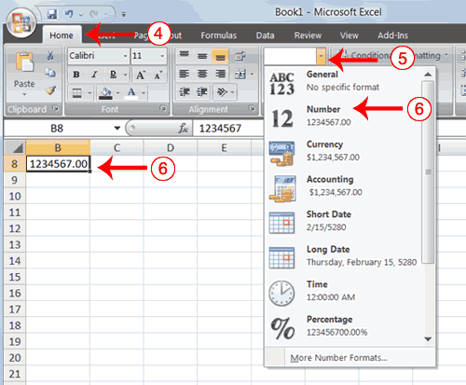

1. Choose the Home tab.
2. Click the down arrow next to the Number Format box. A menu appears.
3. Click Number. Excel adds two decimal places to the number you typed.

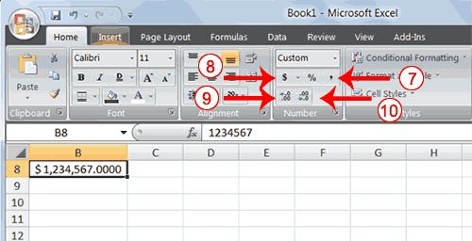

1. Click the Comma Style button Comma Style Button . Excel separates thousands with a comma.
2. Click the Accounting Number Format button Accounting Number. Excel adds a dollar sign to your number.
3. Click twice on the Increase Decimal button Increase Decimal Button to change the number format to four decimal places.
4. Click the Decrease Decimal button Decrease Decimal Buttonif you wish to decrease the number of decimal places.

**Change a decimal to a percent.**

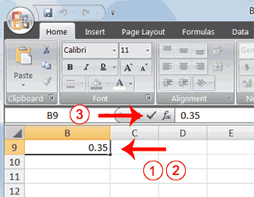

1. Move to cell B9.
2. Type **.35** (note the decimal point).
3. Click the check mark on the formula bar.

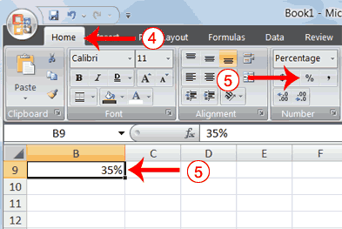

1. Choose the Home tab.
2. Click the Percent Style button Percent Style Button. Excel turns the decimal to a percent.

This is the end of Lesson 2. You can save and close your file. See Lesson 1 to learn how to save and close a file.